|  |
| --- |
|  |
| [Creative Technologies Professionalism]  Technical Report |
| Evaluation of Game Engine Platforms for the Purposes of 2D and 3D Game Design |
|  |
| **Yu-Ching Ho** |
| 20/10/2017 |

|  |
| --- |
|  |

Word Count (excluding references) [ 1850 ]

Module Code: COMP09096

# Table of Contents

**Table of Contents**1

1. **Abstract**2
2. **Introduction**2
3. **GameMaker**2
   1. Dimensions and Animation 3
   2. Learning Curve and Reliability 7
   3. Cost 8
   4. Conclusion 8
4. **Unity**9
   1. Dimensions and Animation 9
   2. Learning Curve and Reliability 12
   3. Cost 12
   4. Conclusion 13
5. **Unreal**13
   1. Dimensions and Animation 13
   2. Learning Curve and Reliability 14
   3. Cost 15
   4. Conclusion 16
6. **Analysis**16
7. **Conclusion**16
8. **References**17
9. **Appendices**17

# Abstract

This report will look at a few of the current most popular engines game developers and will look at ones specifically for 2D, 3D, or ones that have a mix of both. Different levels of skill will be looked at, beginning from absolute novices and progress all the way to indie developers and professional companies with global influence.

The factors that will be looked at are the cost of use for each game engine, how animation, sprites, and levels are taken into consideration with the game engine, learning curve as well as its ease of use generally along with its reliability, all to view the engine at as many different angles as possible to determine which one is the best one to use at each specific level and ultimately, what type of engine is best to build the game in its desired dimension.

# Introduction

Three popular game engines - GameMaker, Unity, and Unreal - will be looked at and deconstructed into subheadings with statistics pulled from their own website or credible sources.

Each subheading will delve into a specific area and then repeat across the board thus after reading this report, the reader will be able to conclude what is the best game engine to use for their own game.

# GameMaker

GameMaker is usually referred as the “go-to” game engine for absolute novices with its easy to learn drag-and-drop (DnD) action sequences or their own scripting language called “GameMaker Language (GML)” for more advanced features in the game.

## Dimensions and Animation

2D is the main dimension for the game and that being so makes it easier for beginners as they only need to worry about x (horizontal) and y (vertical) coordinates for programming and animation. This also means that the game environment can be created using repeated tiles and simple 8-bit or complex well-drawn sprites that interact with the environment mainly in up/down or left/right collision. This means that already one of the major parts of the game is broken down to as simple as possible because there are a lot of free game assets out there with many free-to-use sprites that go through different animation walks like walking, running, jumping, or attacking.

Great games do not necessary need good animation with over textured shadows and layers - Super Mario Land, but if they did want their world to be more interactive, they can overlap layers, use base-height perspective, scale, atmosphere, focus, parallel, or parallax.

Overlap Layers (Panda Jack)

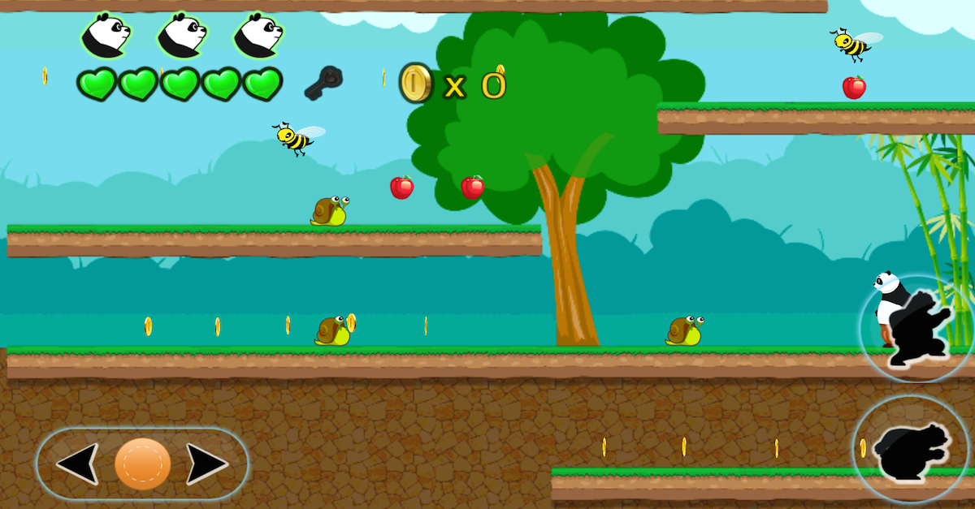

Base Height Perspective (Final Fight)

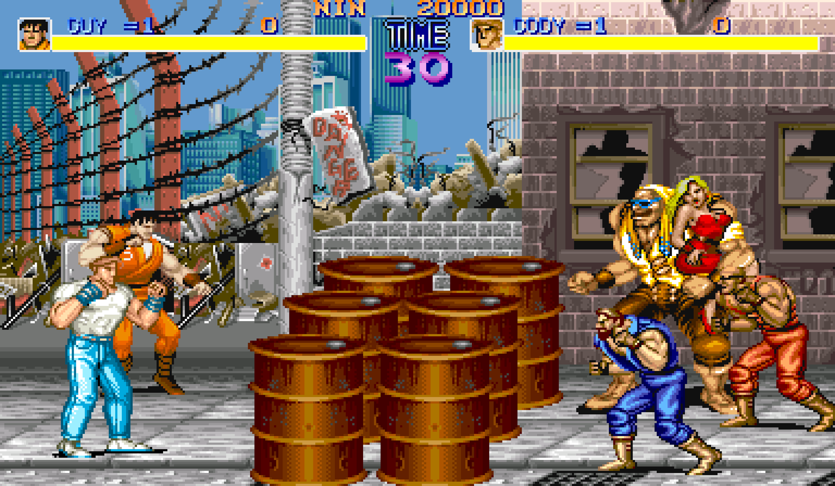

Scale - the greater the distance is, the smaller it is (Lynn and the Spirits of Inao)



Atmosphere (Trine)

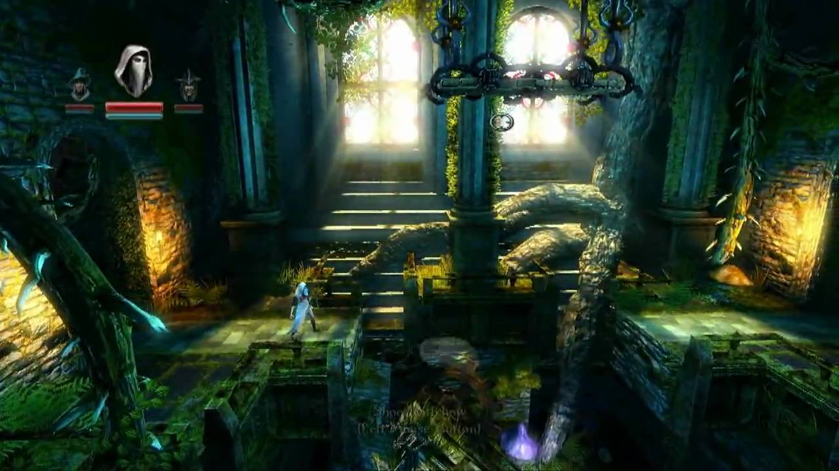

Focus - blur the objects in the far (Capsized)

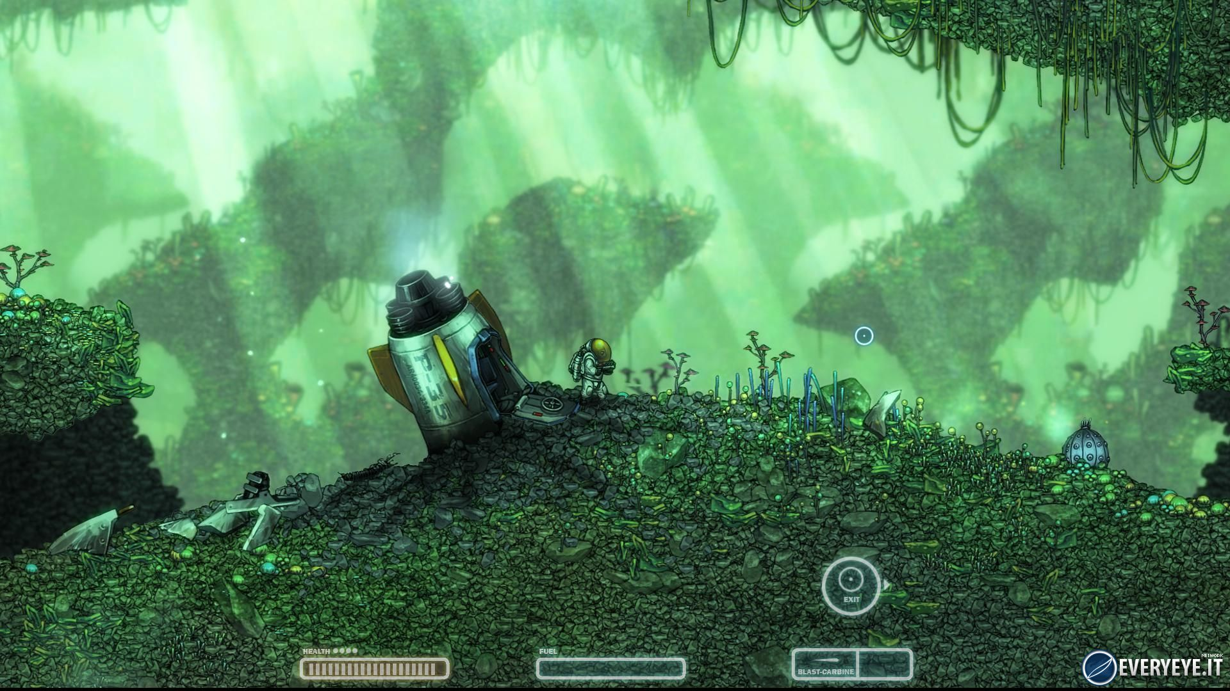

Parallel - the character can walk “behind” a building (Pokemon)

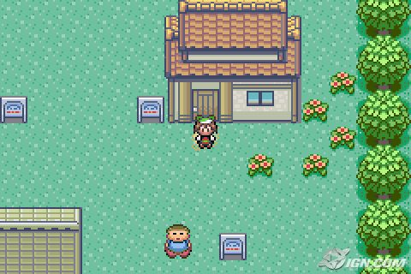

Parallax - layers of objects that move at different speeds (Sonic)

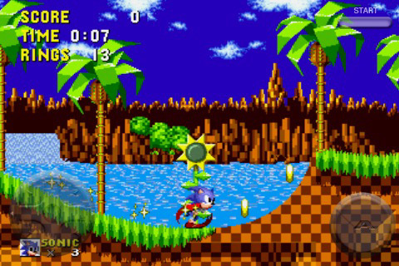

However, if creators did want their game to look 3D - which is not recommended when building in a 2D environment, a method called Isometric Projection where it’s like drawing a cube then adding shadow to create depth.

Isometric (Age of Empires)

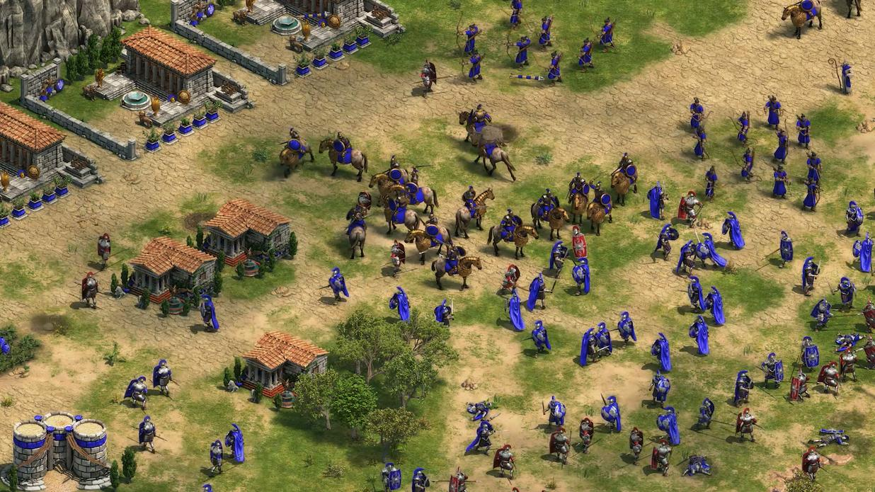

## Learning Curve and Reliability

GameMaker has a very fast, intuitive learning curve via the DnD system and because of that, beginners learn the basics of programming whilst not actually programming and create a game. Then to see how the DnD comes together, the option to view the code is there in GameMaker’s own language - Game Maker Language. GML itself is a fairly simple scripting language to pick up and following the tutorial on the official site or YouTube channels give the creator an introduction to how a programming language works and offers more flexibility and control than the DnD system. Exporting to multiple environments like Windows, Mac, Android, Web, the engine saves the creator from learning multiple languages and or rewriting the game but introduces the cost factor.

## Cost

Getting GameMaker is quite costly - for education institutions:

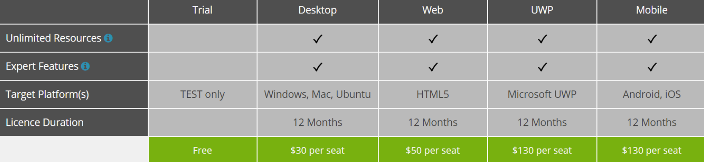

To have the game exported to different environments in personal use, the starting price is $100:

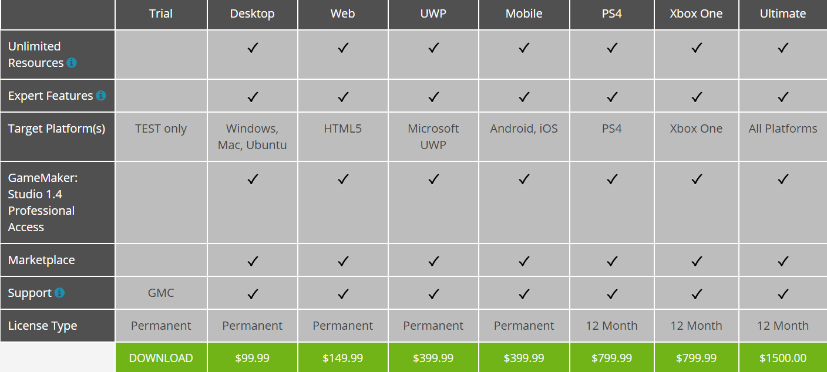***(YoyoGames Get GameMaker Studio 2)***

## Conclusion

Overall, a great engine to start with if creators do not want to be overwhelmed with programming but then begins teaching the basics of programming logic passively, easy to create games by creating them themselves or pulling free resources from the internet and eliminates all the confusing aspects that come with 3D; however as the Trial Version doesn’t offer much and the GameMaker Engine is pricy, this is not a recommended engine for more progressive game developers who want to work in more than 2D.

# Unity

Currently, Unity is the most popular game engine worldwide, used by many companies and ***Top 10 Unity Games (2015)*** has compiled together a list of many famous games produced from the engine; just to mention a few like Assassin’s Creed, Temple Run, Hearthstone, and Kerbal Space Program. From ***Unity’s Public Relations***,it’s a continuous growing market with 34% of top 1000 free mobile games are made with Unity and having touched 770 million gamers worldwide.

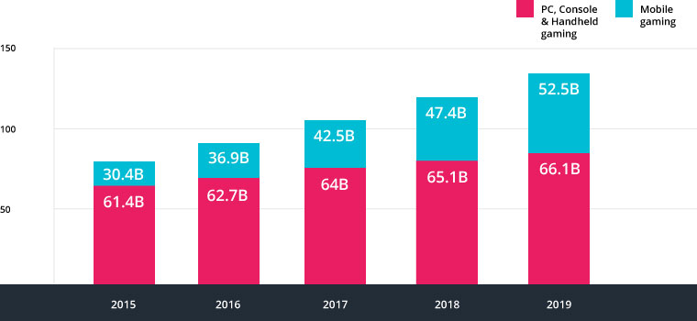

## Dimensions and Animation

The game engine supports 2D and 3D graphics which allows high-end graphics and animation to be made in either the Unity Engine itself, or pulled from the Unity Asset Store which has a lot of professionally-made free and paid for models, particles, textures and much much more; there is also the option of using animation software - the two most famous examples: Blender and Maya, both extremely powerful with Blender being free and Maya having a trial version, to import self-created assets.

Unity is mainly 3D (hence unity3d.com) but both dimensions are equally supported; as 2D and 3D are integrated together, when a 2D project is selected, there is not that much of a difference apart from a couple settings disabled/enabled.

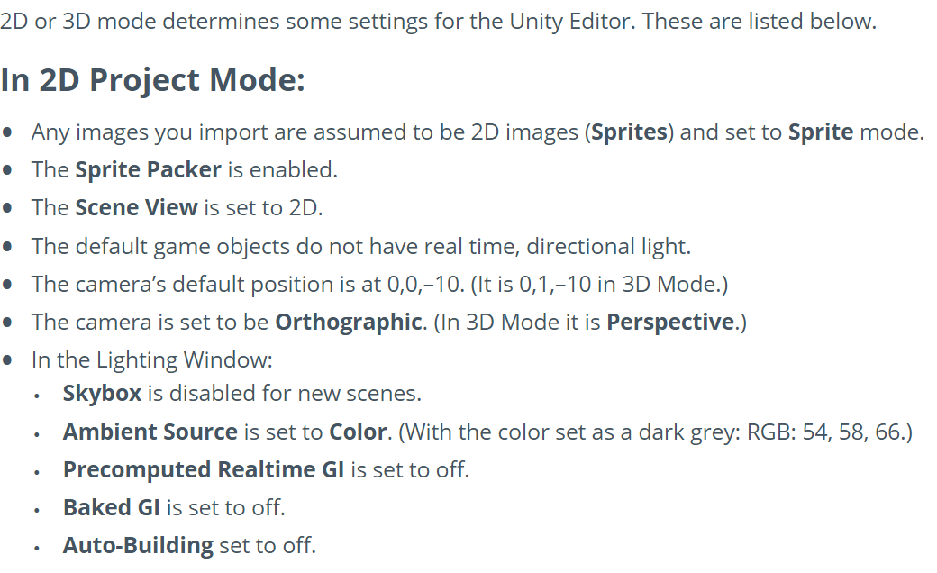

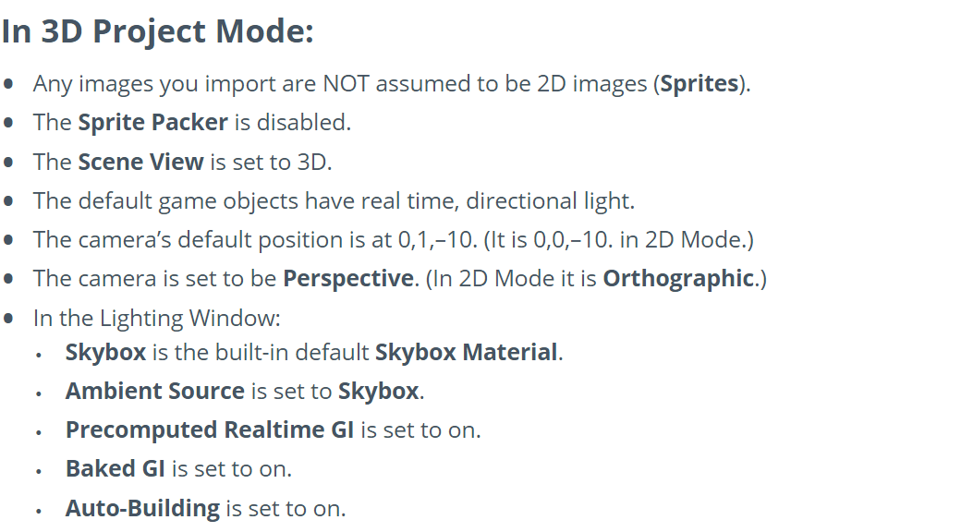

***(Unity Docs 2D and 3D Mode Settings)***

Choosing between the two, there are a number of ways the viewport can change:

In 3D there is full-blown normal 3D, and there is “Orthographic 3D” where it is sometimes called 2.5D as it gives a bird’s eye view of the action whilst the editor, models and assets are all 3D.

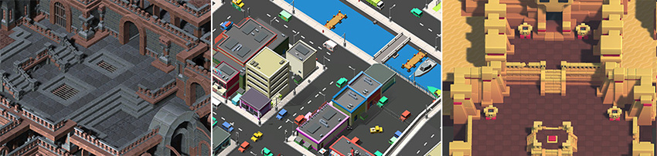

In 2D, there is the full-blown normal 2D using flat graphics and no three-dimensional geometry. Then there is 2D gameplay with 3D graphics - also sometimes also referred to as 2.5D - where the editor, models and assets are all 3D.

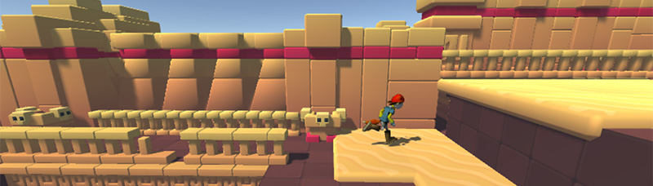

Finally, there is using the 2D editor and flat graphics whilst the perspective and scene view mode is set to 3D.

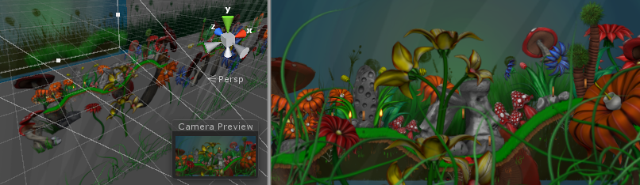

***(Unity Docs 2D or 3D Projects)***

## Learning Curve and Reliability

The learning curve of this game engine is extremely high which is rightly so as it’s professionally used by many global companies. The main language that Unity programs in is C# whilst the two other languages Boo - deprecated in 2015, and UnityScript (Unity’s own form of JavaScript) - deprecated in 2017, are now not supported but if older projects still have Boo’s/UnityScript’s coding inside, the project would still work.

However even with the extremely high learning curve, it is possible to create beautifully simple games by following YouTube tutorials and basic asset store assets and looking at games made from Unity by major game companies, there is no question on its reliability and mentioning that one is experienced with the game engine and has created their own little projects out of fun will put the person miles ahead of the group.

## Cost

One of the amazing things about Unity is that even for free users they can create games for multiple platforms.



***(Unity Blogs Products and Prices)***

## Conclusion

Unity is an extremely powerful game engine, perfect for students/personal developer whom want to develop their skills whilst paying nothing. With many platforms that Unity can export to, little projects developed in university/personal time are great to showcase a person’s skills as the extreme learning curve will develop the user to an industry-level standard.

# Unreal

Unreal Engine is another powerful game engine that is more focused towards the 3D side: first-person shooters being its main target audience but has also been used successfully in other 3D categories.

## Dimensions and Animation

2D can also be used with this engine but with the focus being on 3D, there are a lot more tools, assets, and resources and thus, Unreal can produce mind-blowing graphics without even leaving the engine. The 3D focus makes Unreal specialise and just through its engine, processing, and basic assets, extremely realistic models can be produced and if required, animation like Blender and Maya (again) can be used separately and imported with ease. This makes the 3D animation on another level from Unity - as Unity is more equal on both - with its photoreal rendering, particles and models unmatched.

An example image from the Unreal site is below which shows the difference of graphics between Unity and Unreal:

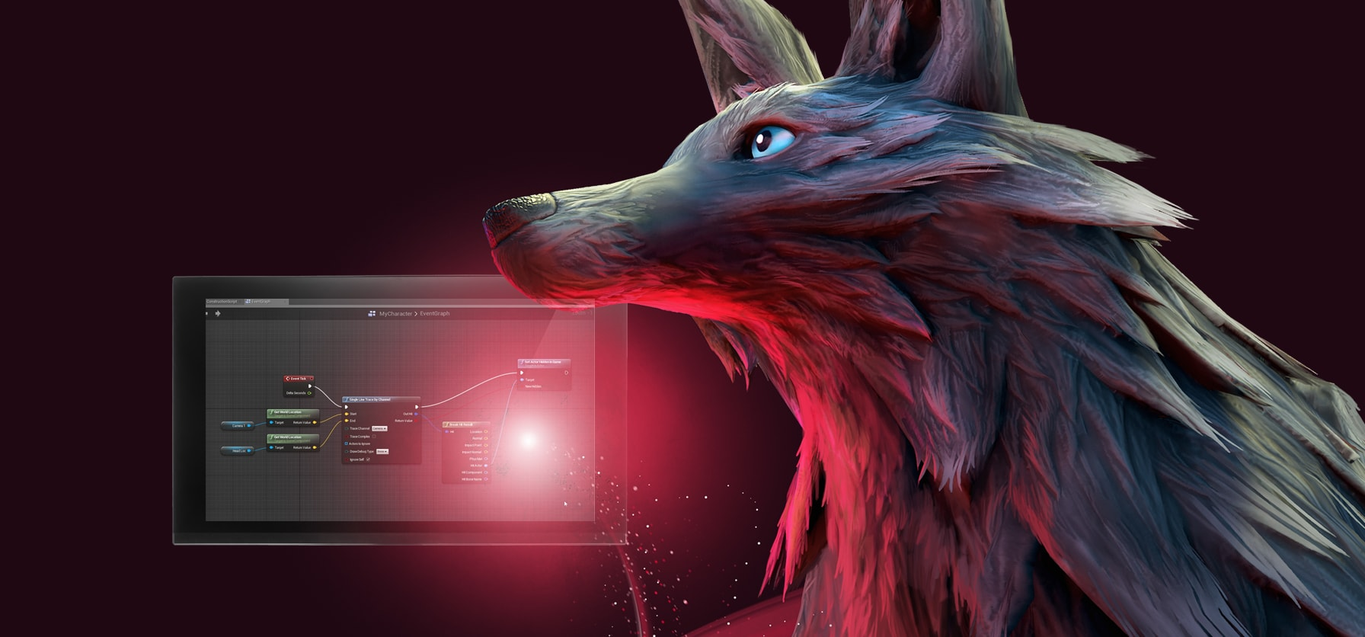

## Learning Curve and Reliability

Again, the learning curve is high for a professionally world-renowned game engine. To help with that, Unreal has developed “Blueprints” which are easily-editable templates that are already pre-programmed to interact with world objects.

Blueprints are like an advanced DnD and they provide great system to quickly prototype games. Unlike GameMaker’s system which is rather simplistic - rightfully so as it’s more of an introductory program - Unreal takes another route by using nodes which split up actions into more and seperate boxes, thus without even touching a single line of code, beginner level creators can develop a simplistic game.

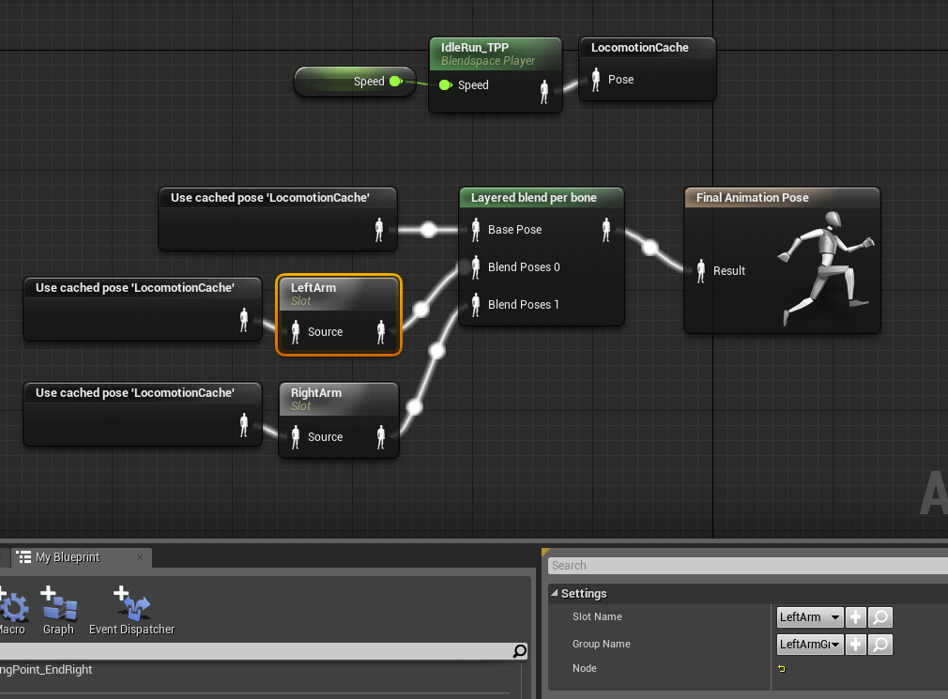

As the games become more complex - the language supported by Unreal - C++ can be used to offer more flexibility, interactions and control within the environment and like in GameMaker, C++ code can be viewed and edited. ***(Unreal Engine About)***

## Cost

Currently with Unreal Engine 4, there is no cost involved with using the full engine and when a game is shipped, a 5% royalty fee on the gross revenue after the first $3000 per product, per quarter. ***(Unreal Engine Blog, UE4 Free)***

For quite literally everyone, it is an amazing way to market the game engine as it provides a powerful learning tool that beginners can use without worrying about cost, learn to an industry standard and start giving back by creating games which generate profit.

## Conclusion

Unreal is an amazing engine to use for people more focused on the 3D, first-person aspect and with no cost to worry about, intuitive interactive user interface, great community with professional learning support, it is hard to see where one would go wrong with Unreal.

# Analysis

Researching and reading about all the different game engines available made it hard to choose which ones to write about; then finally choosing and writing about the ones picked made it extremely difficult as game engines in general are very similar and there is no “right” or “wrong” engine.

For the 2D side of things: GameMaker, Construct, Scratch and a handful more other engines all proclaim to be the best engine to start programming a game as a complete beginner with their own DnD system. 3D: Unity (which is balanced between 2D and 3D), Unreal, CryEngine, RAGE - all have different assets, physic systems, languages, etc and yet are similar.

Between all the top competing game engines, 2D and 3D, there is no “right” or “wrong” engine as it all depends on what the game is going to be, language one is most comfortable in, and looking at which engine supports the most of what the game requests of.

# Conclusion

As a wrap-up, there is no way to tell what the “best” engine is as it all depends on the developer and game intended. The best advice is to find out what type of game and language that you’re most interested in developing in/with and set that engine as the base. Then as the groundwork is laid, expand as much as possible and by doing so, shows future and potential employers a wide range of skills and experience whilst being enthusiastic to step into the unknown.

# References

* YoyoGames Get GameMaker Studio 2 [Online] Available: <https://www.yoyogames.com/get>
* Top 10 Unity Games (2015) [Online] Available: <http://blog.soom.la/2015/01/top-10-unity-games-ever-made.html>
* Unity Public Relations [Online] Available: <https://unity3d.com/public-relations>
* Unity Docs 2D and 3D Mode Settings [Online] Available: <https://docs.unity3d.com/Manual/2DAnd3DModeSettings.html>
* Unity Docs 2D or 3D Projects [Online] Available: <https://docs.unity3d.com/Manual/2Dor3D.html>
* Unity Blogs Products and Prices [Online] Available: <https://blogs.unity3d.com/2016/05/31/new-products-and-prices/>
* Unreal Engine About [Online] Available: <https://www.unrealengine.com/en-US/what-is-unreal-engine-4>
* Unreal Engine Blog. UE4 Free [Online] Available: <https://www.unrealengine.com/en-US/blog/ue4-is-free>

# Appendices

GameMaker Trial Version limitations:

* Cannot create final executable packages for any target platform
* Objects - 15
* Sprites - 20 (no dynamic loading permitted, no SWF or Spine sprites permitted)
* Sounds - 10 (no audio buffers permitted)
* Tilesets - 2
* Scripts - 10
* Paths - 5 (no dynamic path creation permitted)
* Timelines - 2 (no dynamic timeline creation permitted)
* Fonts - 5 (no dynamic font creation permitted)
* Rooms - 5 (no dynamic room creation permitted)
* Shaders - 0
* Included files - 0
* Extensions - 0
* Configurations - 0

Due to the limits placed on certain resources, you will not have access to the functions that can dynamically add or change available resources, so functions like sound_add, timeline_add or sprite_create_from_surface will not be available for use.

Other than those resource limits, there are a few other elements missing from the IDE:

* You cannot set the size of Texture Pages
* You cannot create Texture Groups
* You cannot create Audio Groups
* You cannot use SWF or Spine format sprites
* You cannot create Extensions
* You cannot get assets off of the Marketplace
* You cannot use the built in Source Control
* You cannot import old projects from previous versions of GameMaker Studio
* You cannot import YYZ packages

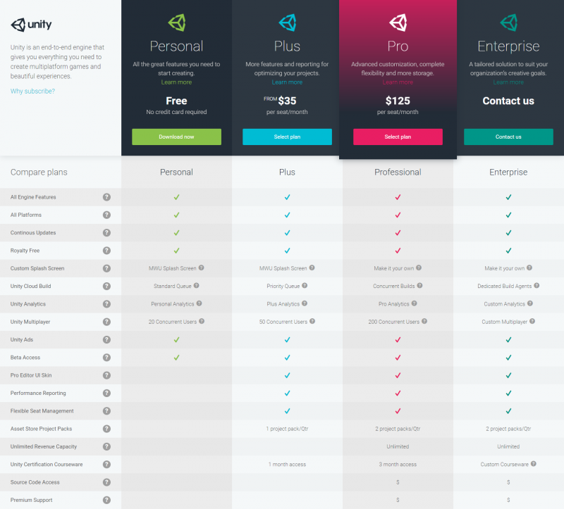Unity Full Pricing List: